**MongoDB Assignment 4**

1. Calculate Total Sales for Each Order.

db.orders.aggregate([{$unwind:"$products"},

{$group:{_id:"$_id",

total_sales:{$sum:{$multiply:

["$products.price","$products.quantity"]}}}}])

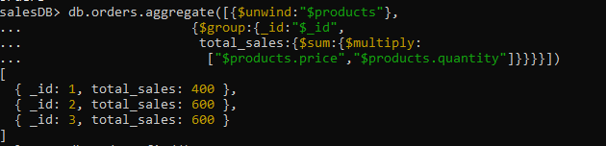

1. Calculate Average Order Value for Completed Orders.

db.orders.aggregate([{$match:{status:"completed"}},{$unwind:"$products"},

{$group:{_id:"$_id",

total_sales:{$sum:{$multiply:

["$products.price","$products.quantity"]}}}},

{$group:{_id:null,avg_sale:{$avg:"$total_sales"}}}])  


1. Find the Maximum Quantity Sold per Product.

db.orders.aggregate([{$unw ind:"$products"},{$group:{_id:"$products.product_id",

max_quantity:{$max:"$products.quantity"}}}])

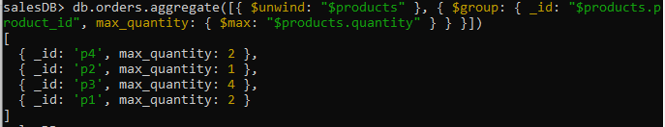

1. Find Total Number of Orders for Each Status.

db.orders.aggregate([{$group:{_id:"$status",

no_of_orders:{$sum:1}}}])

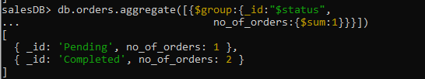

1. Calculate Total Quantity of Products Sold Across All Orders.

db.orders.aggregate([{$unwind:"$products"},{$group:{_id:null,

total_quantity:{$sum:"$products.quantity"}}}])



1. Get Minimum and Maximum Order Dates.

db.orders.aggregate([{$sort:{"order_date":-1}},

{$group:{_id:null,

max_date:{$first:"$order_date"},

min_date:{$last:"$order_date"}}}])

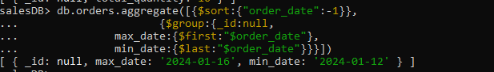

1. Find Total Sales for Each Customer.

db.orders.aggregate([{$unwind:"$products"},

{$group:{_id:"$customer_name",

total_sales:{$sum:{$multiply:

["$products.price","$products.quantity"]}}}}])  
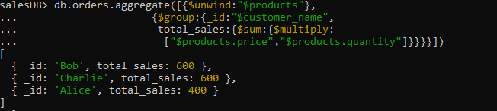

1. Calculate the Total Number of Distinct Products Sold.

db.orders.aggregate([{$unwind:"$products"},

{$group:{_id:"$products.product_id"}},

{$group:{_id:null,distinct_products_sold:{$sum:1}}}])

